Name: Zainab Azeem

Roll no: 21P-8025

Program: BCS

1. Write a python program that prints the following patterns separately one below the other.

Use nested for loop to generate the patterns.

Code

#outer loop represents rows

for i in range(10):

#inner loop represents column

for j in range(i+1):

print("\*",end="")

print()

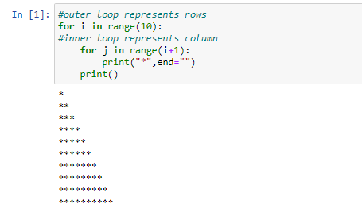

Code

#outer loop print rows

for i in range(10):

#inner loop print column

for j in range(10-i):

print("\*",end="")

print()

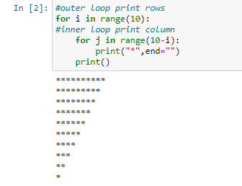

Code

#outer loop represents no of rows

for i in range(10):

#inner loops represents no of column

for j in range(i+1):

print(" ",end="")

for j in range(10-i):

print("\*",end="")

print()

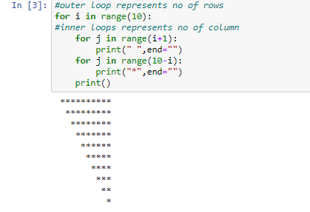

Code

#outer loop print rows

for i in range(10):

#inner loop print column

for j in range(10-i):

print(" ",end="")

for j in range(i+1):

print("\*",end="")

print()

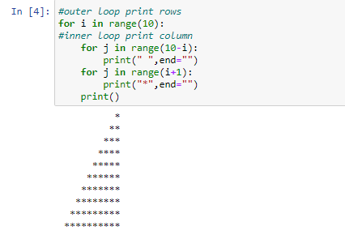

2. Write a Python function to construct the following pattern, using a

for loop. User should enter a symbol e.g \*,^,@,- etc

Code

#asking symbol fromm user

symbol=input("enter symbol")

#outer loop

for i in range(4):

#inner loop

for j in range(i+1):

print(symbol,end="")

print()

#outer loop

for i in range(5):

#inner loop

for j in range(5-i):

print(symbol,end="")

print()

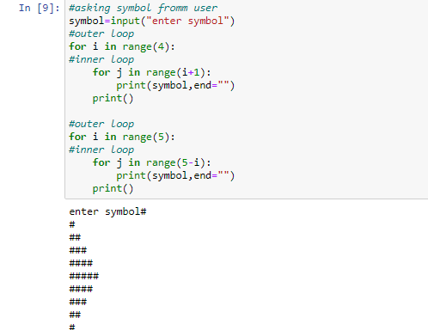

3. Write a program the prompts the user for information for three students. For each student

prompt for the student ID and three quiz grades. Use a nested loop, where the inner loop

prompts for the three quiz grades. Print the student’s name and average – formatted to

two decimal places.

Code

#finding average of students using nested loop

for name in range(3):

sum=0

name=input("enter name:")

for score in range(3):

score=int(input("enter score:"))

sum+=score

average=sum/3

average=round(average,2)

print(name)

print(average)

print()

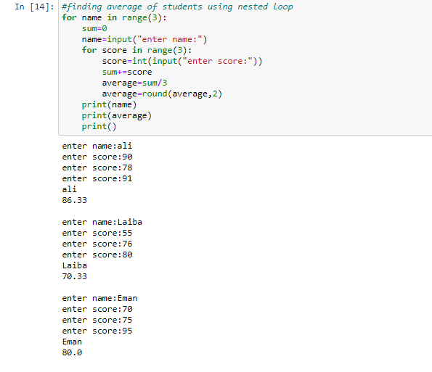

Additional Task

4. Write a Python function to construct the following pattern, using a

for loop. User should enter a symbol e.g \*,^,@,- etc, the number of rows and your

function should a pattern like this of that symbol.

Code

#program to form a pyramid

n=int(input("enter rows:"))

symbol=input("enter symbol:")

for i in range(n):

for j in range(n-i):

print(" ",end="")

for j in range(i+1):

print(symbol,end="")

for j in range(i):

print(symbol,end="")

print()

